FARMER’S BUDDY

1.Introduction

1.1 Purpose

This document provides overview of the project farmer’s buddy. It is the agriculture portal which provides solutions to small farmers and agriculture students of India. Besides Salt & fertilizer analysis for particular region this portal also helps farmers to know about government loan and insurance schemes. It also helps them make decisions on mandi/market and best prices. NGOs are trying to spread messages to make agriculture more eco-friendly through this site.

1.2 Scope

This document provides an architectural overview of the Farmers Buddy System. It provides basic soil analysis for all regions and suggestions on which fertilizers to use where & how much? Which crop, herb or vegetable can be grown where and in which season? It would maintain a database of what has been grown in the past few years in a particular area, which crop has produced the max output in terms of money and which also is the most beneficial for the land too, because since there would be fertilizers to be used in various aspects of the farming. This will apply to all the farmers what-so-ever, it doesn’t matter what are they farming, they just need to submit their data and details to the main database and then their details would come up on the main sever and this would include them in the system.

1.3 Definitions, Acronyms and Abbreviations

HTML: Hypertext Markup Language is a markup language used to design static web pages.

EJB: Enterprise Java Beans.

J2EE: Java 2 Enterprise Edition is a programming platform, part of the Java Platform for developing and running distributed multitier architecture Java applications, based largely on modular software components running on an application server.

DB2: DB2 Database is the database management system that delivers a flexible and cost effective database platform to build robust on demand business applications.

WAS: Web sphere application server is an application server that runs business applications and supports the J2EE and web services standards.

HTTP: Hypertext Transfer Protocol is a transaction oriented client/server protocol between web browser & a Web Server.

HTTPS: Secure Hypertext Transfer Protocol is a HTTP over SSL (secure socket layer).

1.4 References

IEEE SRS Format.

Problem Definition (Provided by TGMC).

1.5 Overall Description

This document present the architecture as a series of views; use case view, logical views, process views and deployment view.

General description

2.1 Product Perspective

This system comes as to help and facilitate a farmer's cultivating habits and advise them to earn more profit and help them grow. This would be achieved with maintaining a database of all farming knowledge onto computer servers and make them available to the farmers through internet to anywhere. All farmers, field officers, manufacturers and experts functionality must be available from PCs with remote connections. This means that this should be available to all farmers and other users of the system from anywhere in the country through internet. · The web pages (XHTML/JSP) are present to provide the user interface on customer client side. Communication between customer and server is provided through HTTP/HTTP protocols.

2.2 Product Function:

*Track Account Level Data:* In this module, receivables from customer are maintained.

*Service Level Agreements:* It contains the agreements of providing the services related to product and customer.

*User Contact Information:* It maintains all the details (Personal, Official, Contact, and Company) of the customer.

*Product Ownership Details:* It maintains the information that does which customer own which product.

*Track Support Transactions:* Maintenance of transactions related to the services provided to the customer in the form of support.

*Maintaining Logs:* Activities of the System Users can be tracked through the logs, which is maintained by the system.

2.3 User Characteristics:

Every user should be comfortable of working with computer and net browsing. He must have basic knowledge of English too.

2.4 Constraints:

GUI is only in English.

Login and password is used for identification of customer and there is no facility for guest.

This system is working for single server.

There is no maintainability of back up so availability will get effected.

Limited to HTTP/HTTPS.

Assumptions and Dependencies:

The details related to the product, customer, payment and service transaction provided manually.

Administrator is created in the system already.

Roles and tasks are predefined.

Specific Requirements

3.1 Functional requirements

3.1.1 Functional requirement 1

3.1.1.1 Introduction

Information about major crops and their mandi prices should be published daily.

3.1.2 Input

Farmer is logged in.

3.1.3 Processing

Farmer can view mandi prices of a mandi which is closest to him and which offers him best price on his products.

3.1.4 Output

User can see various details related to crops and their prices

3.1.2 Functional requirement 2

3.1.2.1Introduction

User enters the username and password and admin allow him to access the website.

3.1.2.2 Input

Admin is logged in.

3.1.2.3 Processing

User gives the username and password. Admin check this information and check its validation. If it is valid user will be successfully logged in. If the username and password is not valid a message sends to user for correct username and password.

3.1.3 Specific requirement 3

3.1.3.1 Introduction User submits the problem to get answer of the problem.

3.1.3.2 Input

User is logged in.

3.1.3.3 Processing

After login, the user provides the problem definition and submits it to get solution.

3.1.3.4 Output

Expert access the problem definition and checks validation of this problem. If it is valid expert will provide the solution of it. If problem is not valid an error message will be display.

3.1.4 Specific requirement 4

3.1.4.1 Introduction

Admin allows to User to access the website according to fill up the form information.

3.1.4.2 Input

User has to submit his details.

3.1.4.3 processing

User provides the username, password and other detail for registration. Admin checks these details.

3.1.4.4 Output

If it is valid then it is successfully saved. If these information contains any error a message goes to the user to fill again the form.

3.1.5 Functional requirement 5

3.1.5.1 Introduction Manufacturer provides the training for his new tools.

3.1.5.2 Input

Manufacturer is logged in.

3.1.5.3 Processing

Manufacturer provides the training schedule details and for new tools and saved it.

3.1.5.4 Output

Farmer gets the training schedule in non-editable mode.

3.1.6 Specific requirement 6

3.1.6.1 Introduction

Farmer can view govt. Information

3.1.6.2 Input

Farmer is logged in.

3.1.6.3 Processing

Field officer is logged in. Normal flow of events: Field officer provides and updates the govt. policy details and saved it if changes are made.

3.1.6.4 Output

Farmer views the govt. scheme innon-editable form provided by the field officer.

3.2 External Interface Requirements

Registration: When a person enters into the system for the first time, he/she should identify themselves as to which category of uses do they belong to, and then go onto to register themselves. Every user of the system viz. field officer, farmer, expert and manufacturer should register them self with the system and get authentication from the admin of the system. While registering in the system the user need to provide all the information being asked in the registration form.

Login: user has to authenticate himself every time he wants to access the system by providing username and password. This would enable him to go to his account and check out things which he could depending on his account type.

3.3 Performance Requirements

The manufacturer could advise and provide some training activities for the farmers on new technology and tools. Farmers would know what is latest and new in the farming technology, what is that they should look forward. This is again important because farmers should have up-to-date information about what all farming tools are there in the market which could satisfy their needs.

3.4 Design Constrains

The field officer could help farmers by becoming an interface between farmers and the system and could help them identify their needs. Field officers would help farmers to get to their problems without wasting time on unnecessary details.

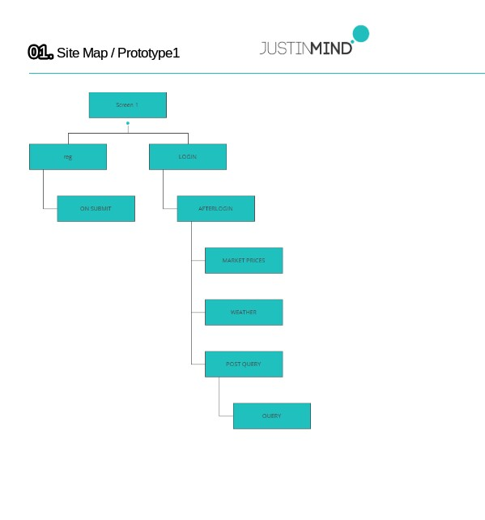



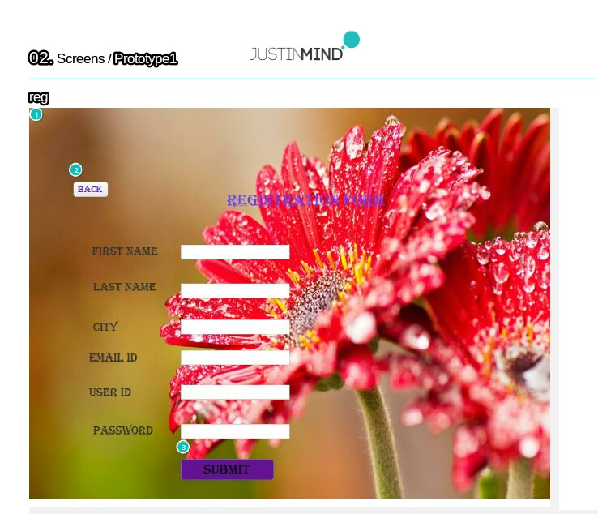

Interactions

1.on click: sets image ‘none’ to ‘image_1’->

2.on click: goes to ‘screen 1’->

3.on click: goes to ‘ON SUBMIT’->



Interactions

1.on click: goes to ‘Screen 1’->

The user has to fill the details ,which are mentioned in above registration form. User is redirected to this page just by clicking the Registration hyperlink on the home page.

On clicking the submit button ,user details are saved into the database.The fields email-address and login id provided by the user must be unique.Then only details of that particular user are saved ,otherwise alert message will be displayed.

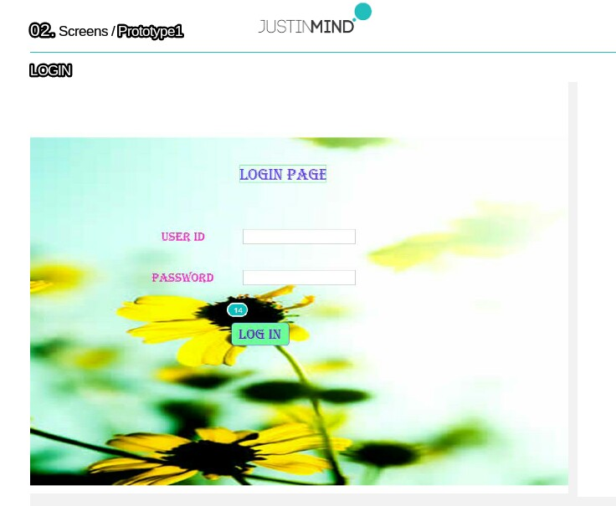

Interactions

1.on click: goes to ‘AFTER LOGIN’->

By clicking on the login hyperlink, on the right frame of the home page, login page is displayed.

Only user who are registration are allowed to login users provide their unique user id followed by the password in the text field and by clicking on the sigin button they will redirected to other webpage.

If the user forget their password ,then on clicking the forget password help him to recover the account.

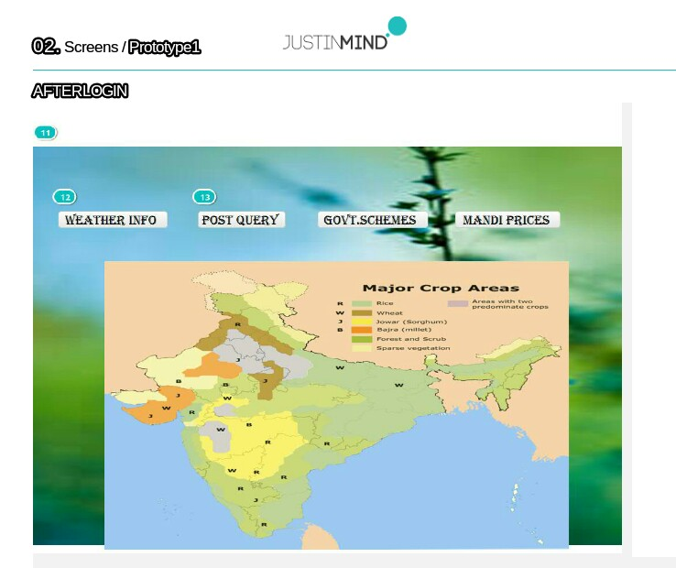

Interactions

1. on click: goes to ‘MARCKET PRICES’->

2. on click: goes to ‘WEATHER’->

3. on click: goes to ‘POST QUERY’->

The above screen is the homepage for the project Farmer Buddy. This homepage consists of these frames

1. First frame is at the top of the page consists of a background image and logo of project followed by title of project. HOME, REGISTATION , LOGIN, GENERALINFO are the hyperlinks, whenever user clicks on these links , he is redirected to other wed pages.
2. Left frame consists of image related to our project

Ex: Images related to the fields.

1. Right frame consists of general information about the web page and also consists geographical indication, just to highlight the webpage.

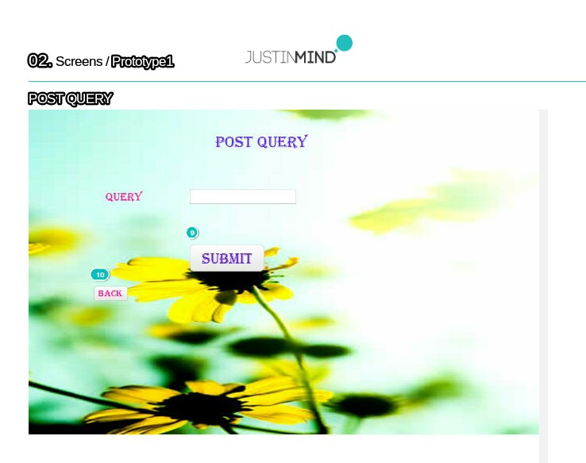

Interactions

1.on click: goes to’QUERY’->

2.on click: goes to ‘AFTER LOGIN’->

The above screen provides the solutions to user which post the query .The user may also have the details of the expert which provides the solutions to his query , which will help him to contact that expert whenever needed.

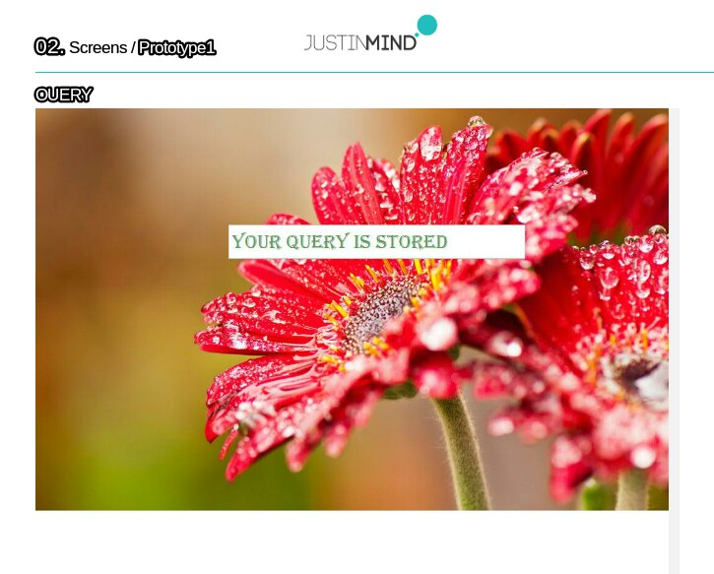

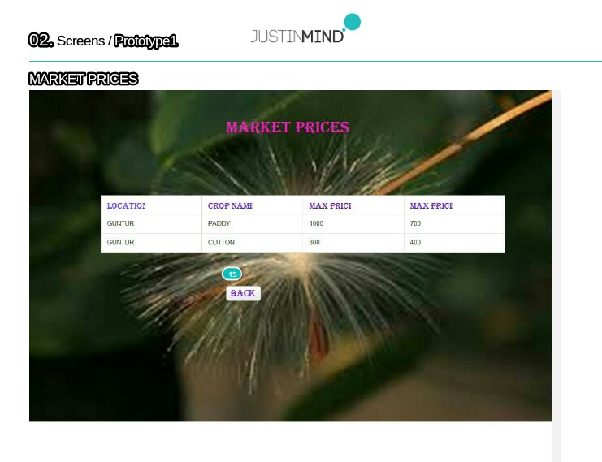

All the above screen are the report screen, where the user can get by just clicking the hyperlinks weather info, post query, govtschemes and mandi prices.

This screens provided all the information regarding the weather, market prices etc

Ex: user can get market prices related to particular crop based on particular locations.

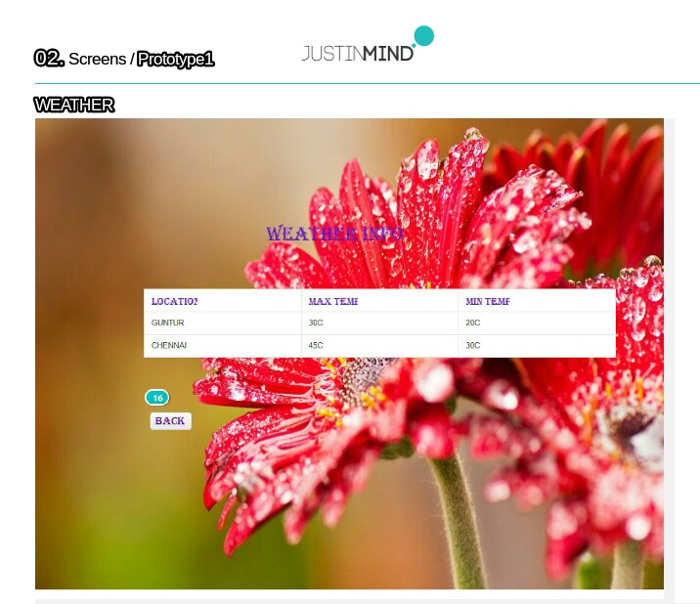

Interactions

1.on click: goes to ‘AFTER LOGIN’->

Daily weather updates are sent to user via email or by message to their phone number.

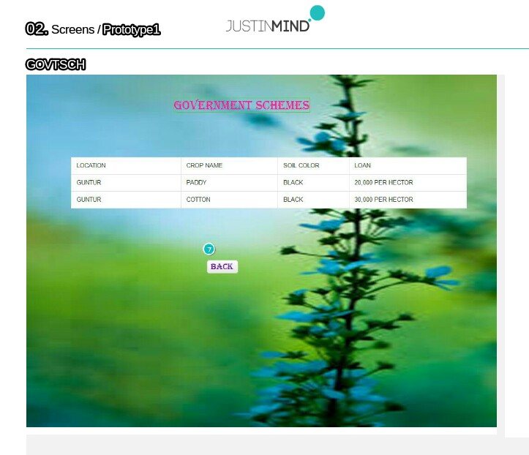

Interactions

1.on click: goes to ‘AFTER LOGIN’->

All the above screen are the report screen, where the user can get by just clicking the hyperlinks weather info,govtschemes.

User may ask information about the amount the fertilizer to used to a particular crop by posting a query .Experts provide solution in the form of the above report screen. It contains various text fields (soil name, type, crop name ,cost of fertilizer, use of fertilizer per hector).

The user may get this information, whenever the expert provide the solution to his post, notification regarding to his aspect are send to the user.

3.5 Maintainability requirements

A farmer could submit his problem to the system and ask for solution. The problems could vary from farming issues to technical ones. They can ask about which crops would suit their needs, since there are people who do not have the knowledge and skill to look for their issues for themselves on the portal, for them, they could simply submit their issues and get the result of their problems what so ever. An expert who may not be local to the village could provide some expert help by sitting at some remote place. This can only become possible due to the remote server which would let the experts reach out to all farmers and give them necessary help.

3.6 Availability Requirements:

The field officer could provide the farmers with the pricing list so that they may not face some fraud. This is an important part because when farmers to go mandies they face dalas and food dealers who buy food stocks from farmers at cost of their will and do not follow any specifications given out by the government.

3.7 Database Requirements:

The field officer could provide the farmers with the weather reports help them cultivate more. Correct weather report helps farmers to grow crops according to the water contents and other information about the soil which would range from the information from the reports submitted by the field officer.

3.8 Documentation Requirements

The field officer could provide awareness drive on Govt. schemes specially loan and insurance based for farmers. This would enable farmers to grow crops whose seeds might not fit into the budget of the farmers but from government loans, he could grow any crop which suits the needs of the particular soil types and the region.

**Data Flow:**

|  |  |  |
| --- | --- | --- |
| **Actions** | **Process** | **Databases** |
| Visitor | Registration | Details |
| Farmer | Get price,  get weather-updates,  process-forum | Crop database,  weather database |
| NGO’s | Sent mail | Details |
| Foreign Agriculture experts | Sent-tool Info | Tools Database |
| Experts | Provide-solution | Solution Database |

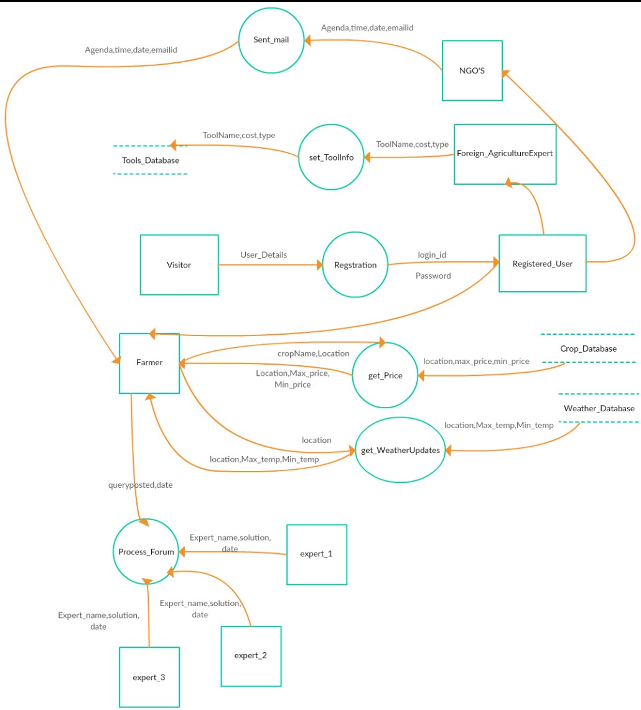

**Table Attributes:**

|  |  |
| --- | --- |
| **Table Name** | **Attribute** |
| Training | Company-name,  agenda, time, date, man-email-id |
| Fertilizer | crop name, cropid,  soil name, soil type |
| Fertilizer info | fert-id ,fert-name ,  fert-rate ,quantity ,max-temp |
| Weather | location ,date ,location-id,  rain-info, min-temp, max-temp |
| Govt-schemas | crop-id, crop-name, date, amount, loan interest |
| Tools | crop-id, tool-id, tool-name, cost |
| Solutions | sid, expt-emailid ,  expt-name ,solution |
| Crop | crop-id,crop-name,sed-id,seed-name,seed-price,quantity,max-price,min-price,loan,date |
| Query | qid, query, date |

**Relationships Attibtes:**

|  |  |
| --- | --- |
| **Table** | **Attributes** |
| Fertilizer-query | Fert-name, fert-id, crop-id,  crop-name |
| Query solution | qid, sid, sdate |

